**In P.E we will be learning about different strokes in Tennis, throwing and catching skills and using tactics in games against peers.**

In our R.E topic “From Resurrection to Pentecost” we will be learning about the Resurrection of Jesus, following the Ascension and glorification of Jesus culminating in the sending of the Holy Spirit at Pentecost.

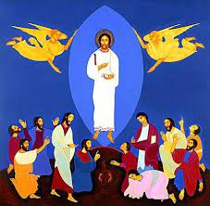

**In our Mathematics learning the class will be looking at:**

* Place value within 50
* Geometry- Position and direction
* Measurement – Money
* Multiplication and Division

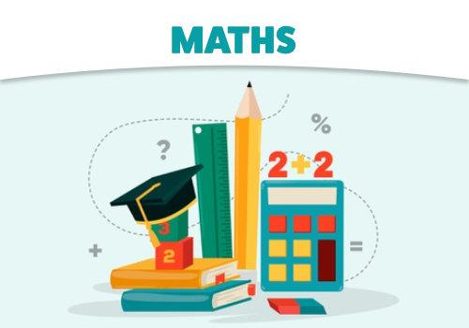

In Computing, we will learn to understand what algorithms are (instructions): how they are implemented as programs on digital devices: and that programs execute by following precise and unambiguous instructions, using Beebots.

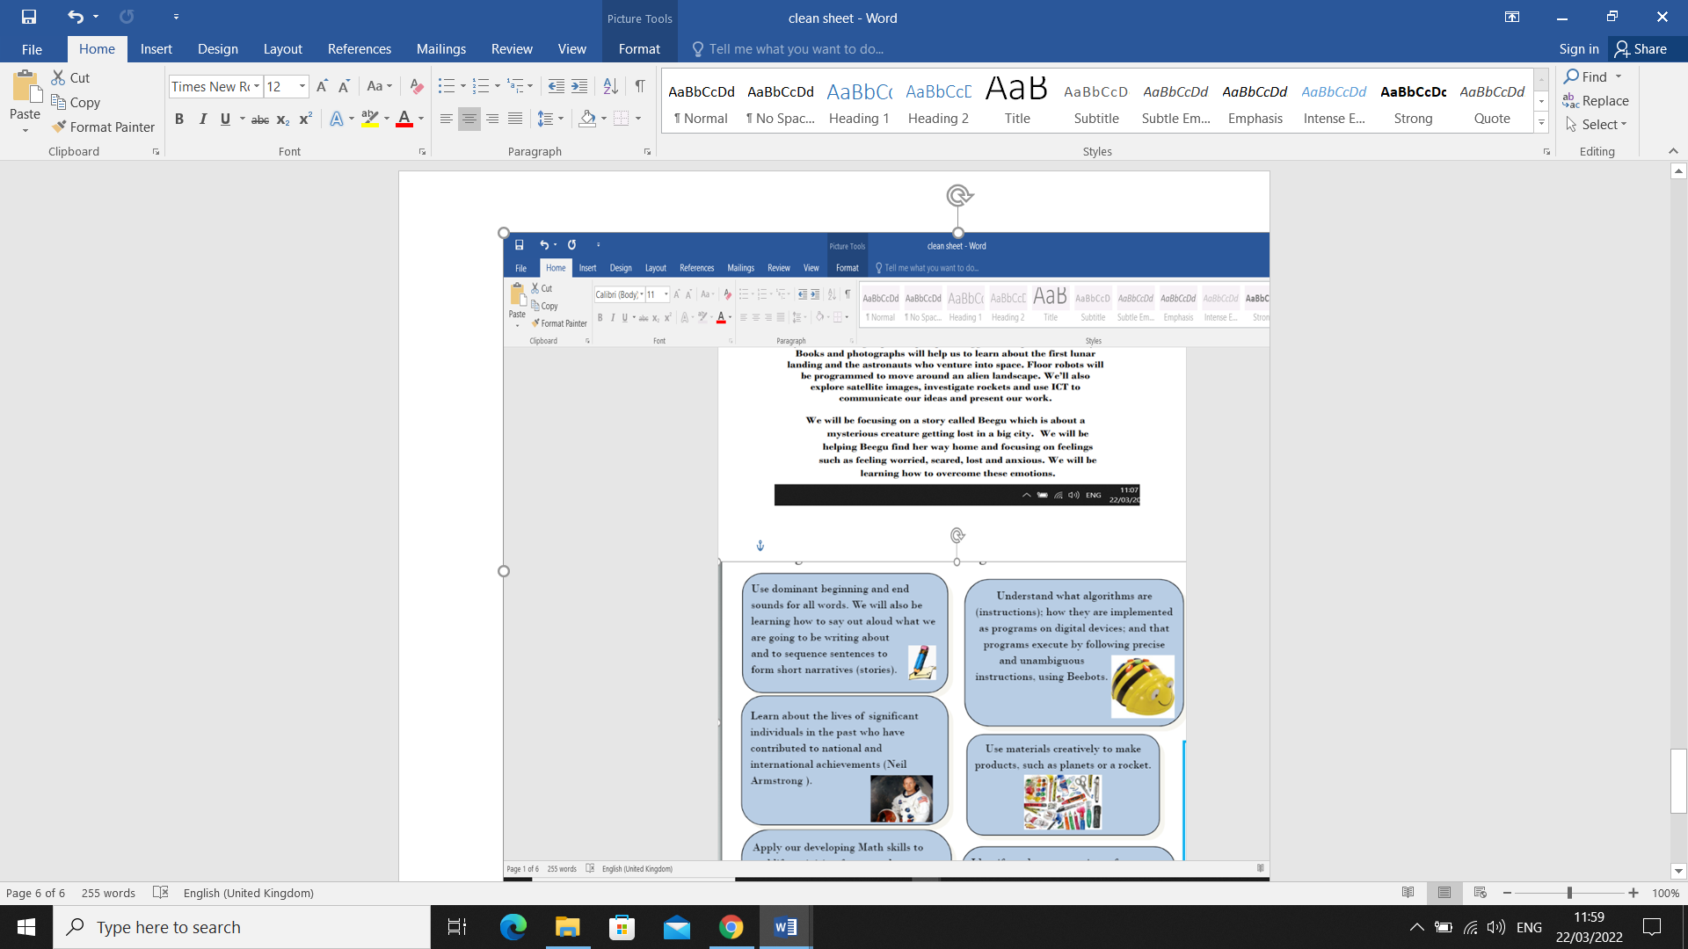

**Year 1 Summer 1 Half Term Topic:**

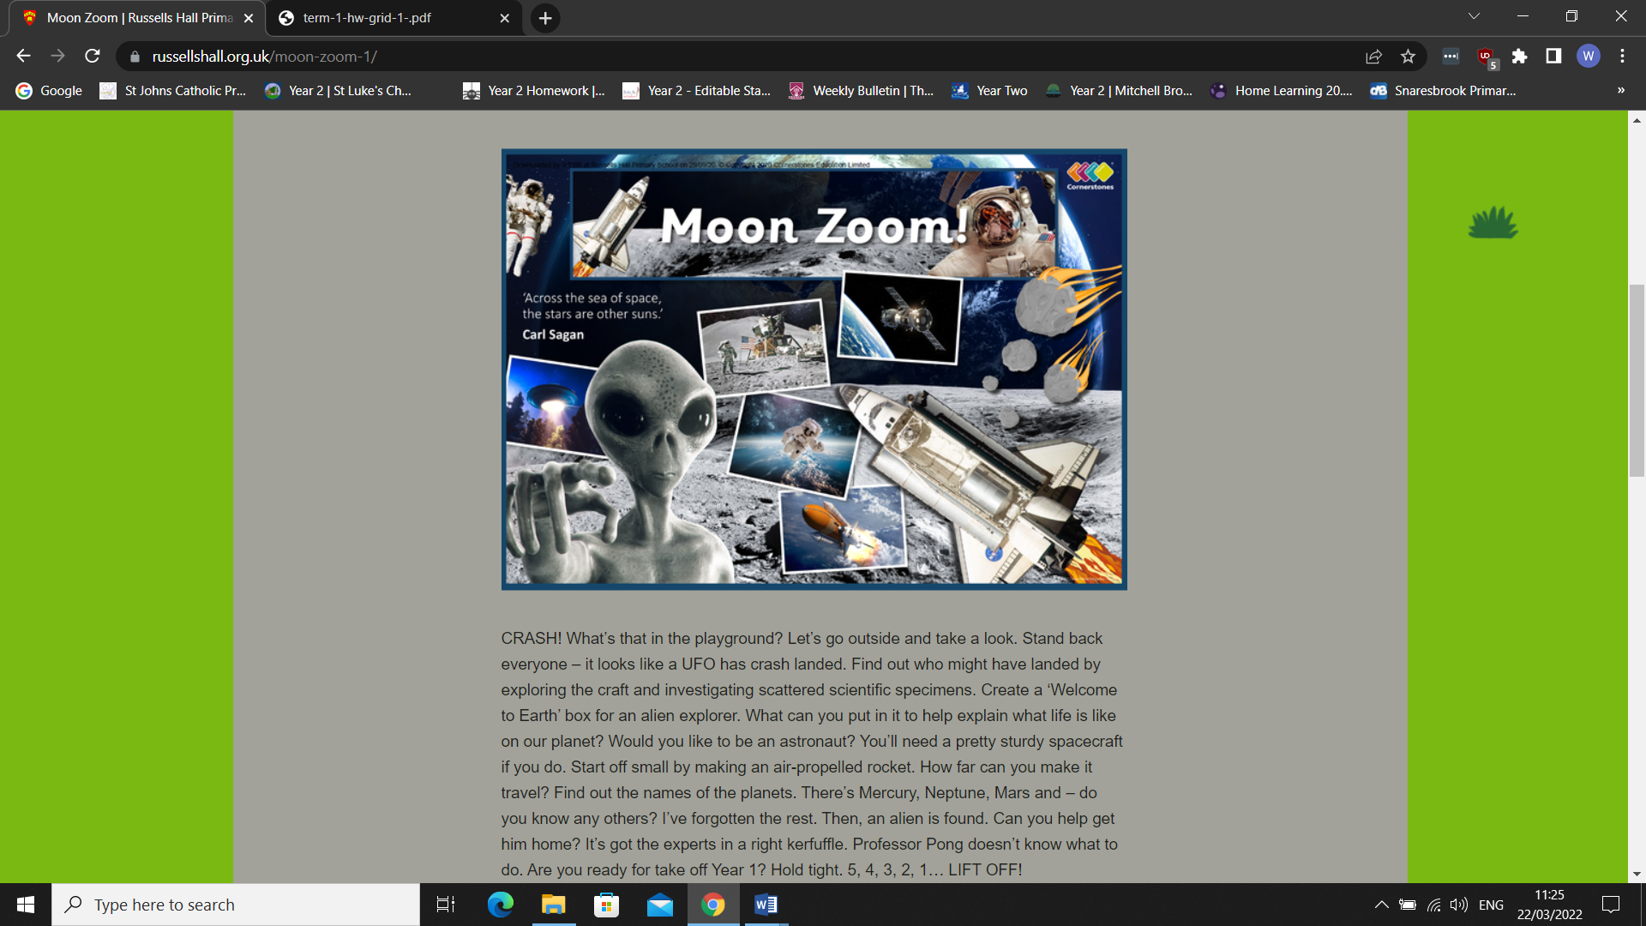

In Science we will be learning all about the SPACE. We will be learning some facts about the planets in our Solar System and we will be labelling the planets and learning their order.

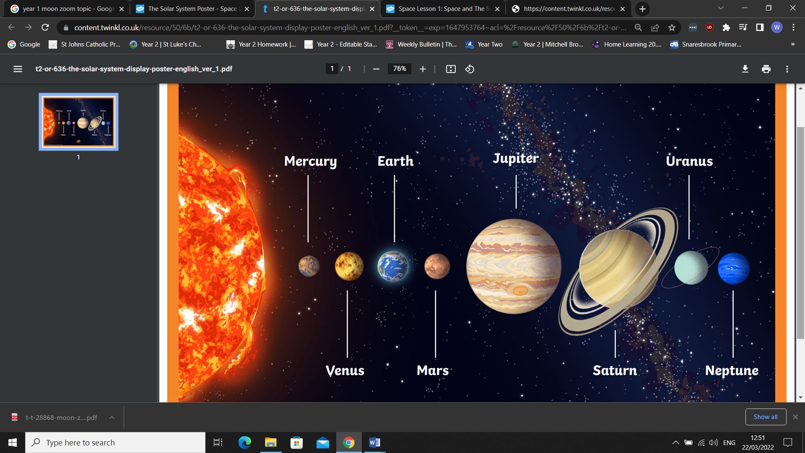

**LITERACY**

As Writers we will be writing recounts of our findings and retelling stories from different characters’ aspects. We will be looking at Space themed books. The children will be writing nonfiction pieces about planets and Astronauts.

As Readers we will be enjoying Beegu, Man on the Moon and Aliens Love Underpants Save the world. In addition to this we will be looking at a range of fiction and non-fiction books based around Space.

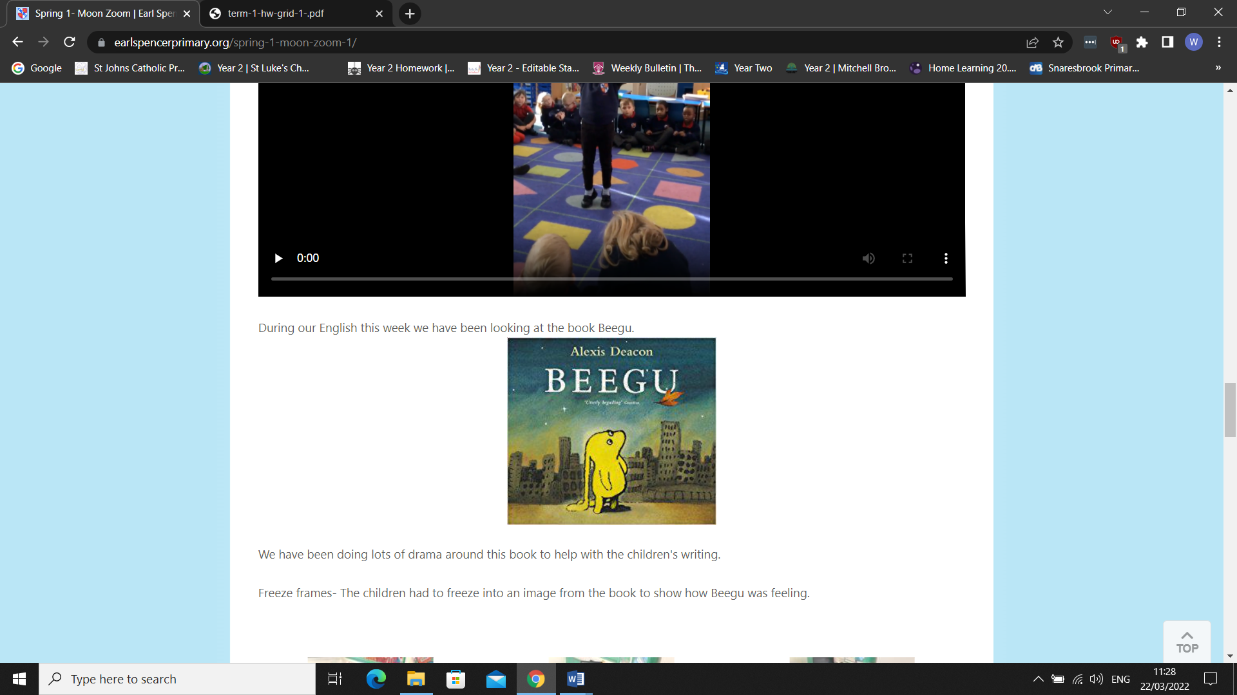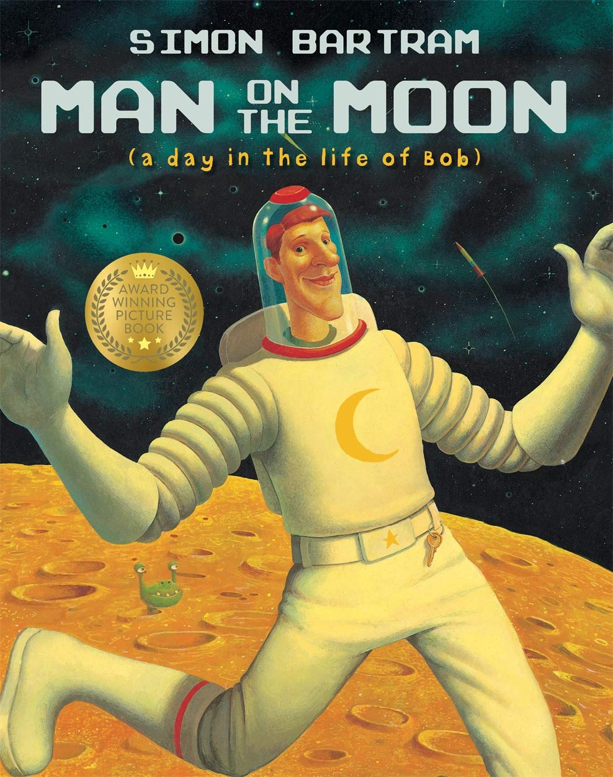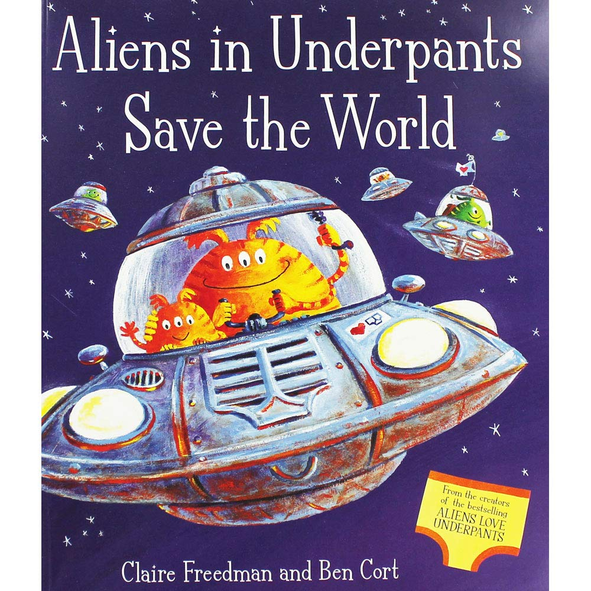

**ART&DT**

In Art we will be completing paintings of the solar system and use a range of materials. We will also explore the work of Peter Thorpe whose passion is space travel. In D&T we will make and design our own junk model rocket ships.

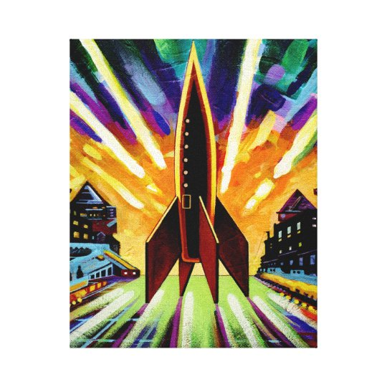 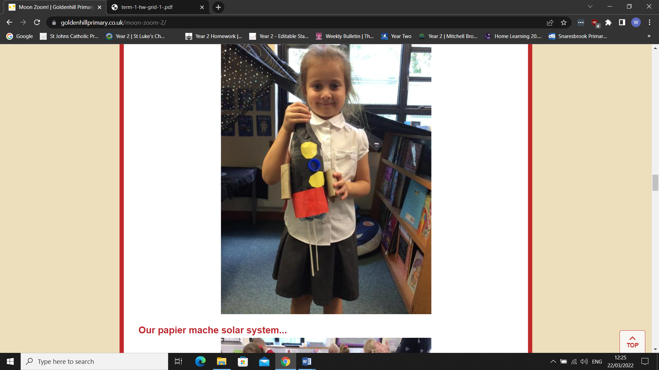

**TOPIC**

In History we will be exploring and learning about famous people that have been important in space exploration. We will be comparing the differences between current astronauts, such as Tim Peake, and those from many years ago, such as Neil Armstrong.

.

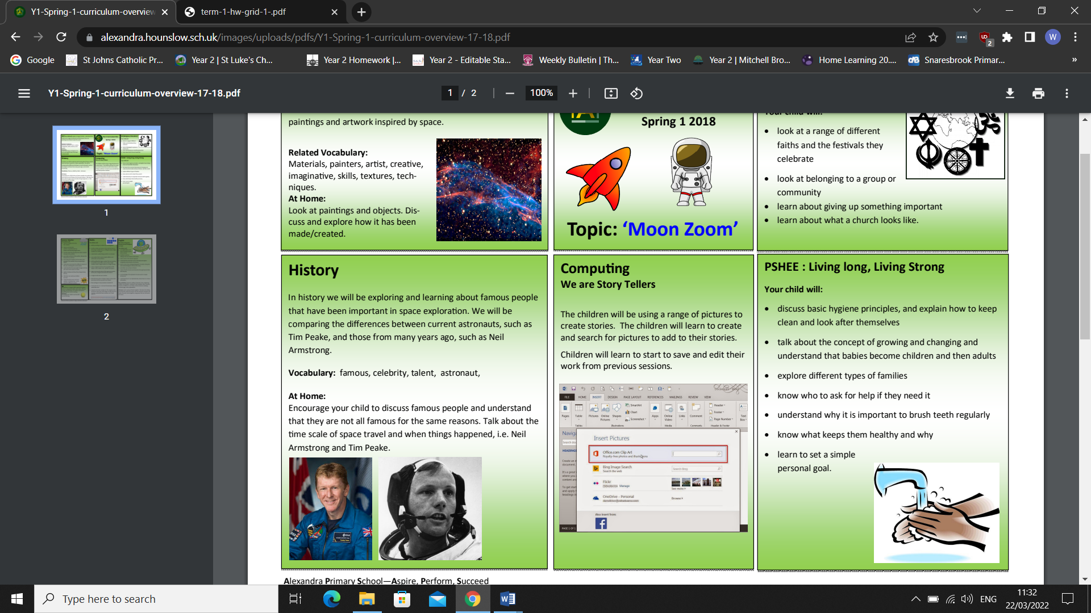

In PSHE we will explore how human beings are relational by nature and are called to love others in the wider community through service, through dialogue and through working for the Common Good.