In PE we will be learning about: Football

* Can send a ball using feet and can receive a ball using feet. • Refine ways to control bodies and a range of equipment. • Recall and link combinations of skills, e.g. dribbling and passing.

In PSHE our topic is: Healthy Me - Being and keeping safe and healthy. We’ll be encouraging children to:

* Have a healthy life style – physically, mentally and emotionally
* Teach all the children the value of loving and respecting their body

**Year 2 Autumn 2 Topic: Street Detectives**

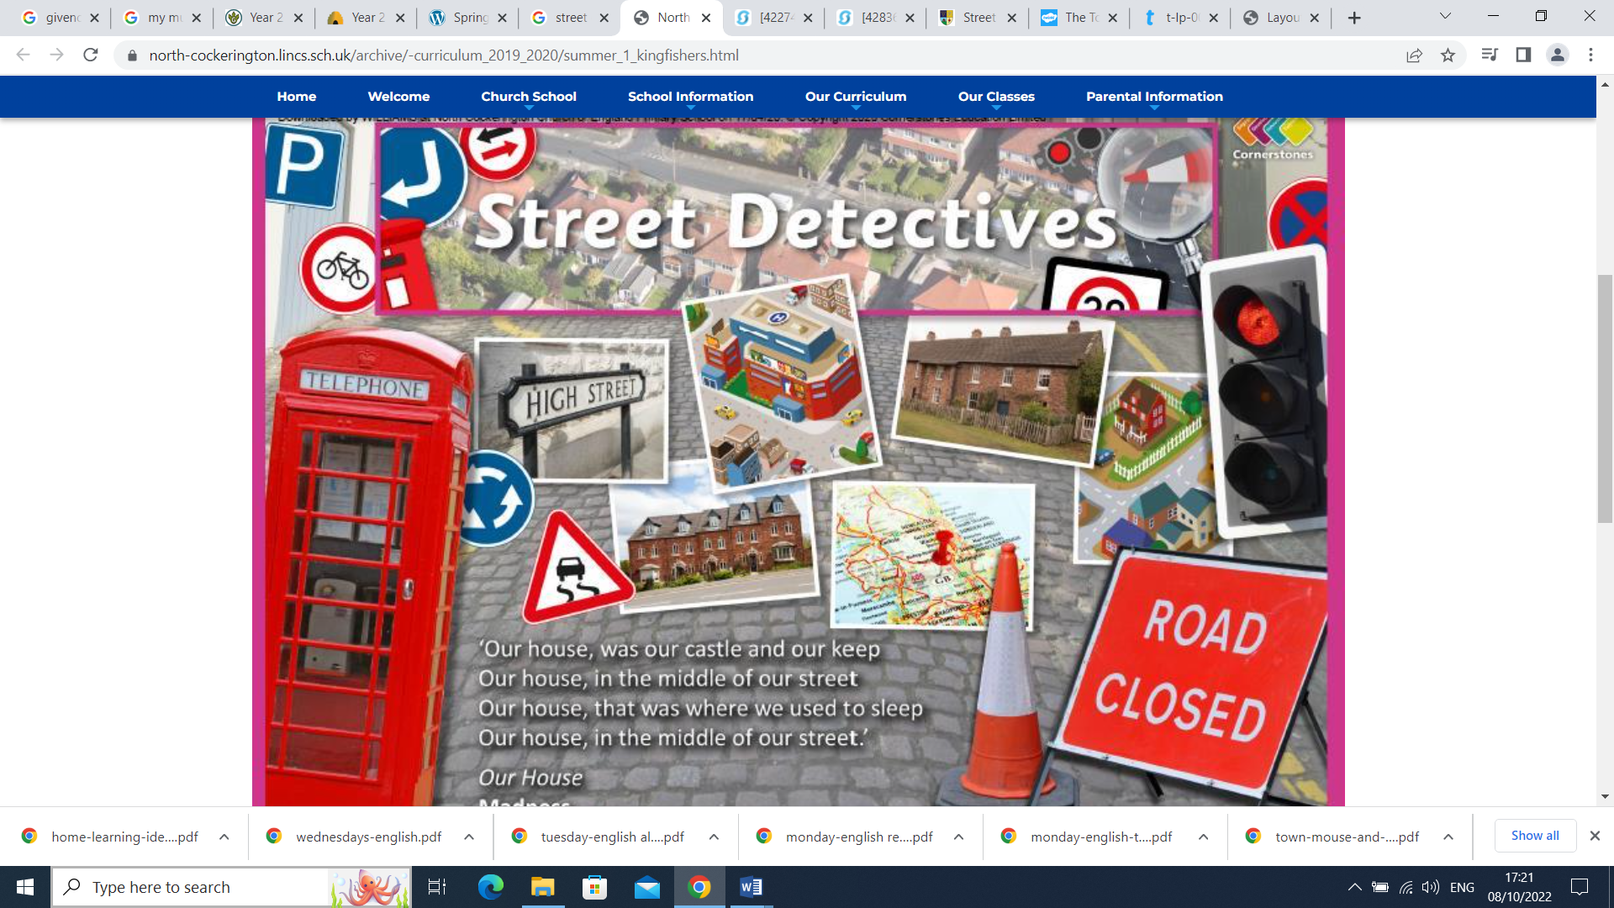

In Computing we will be learning about creative media-

* Digital Photography
* Online safety—self-image and identity online

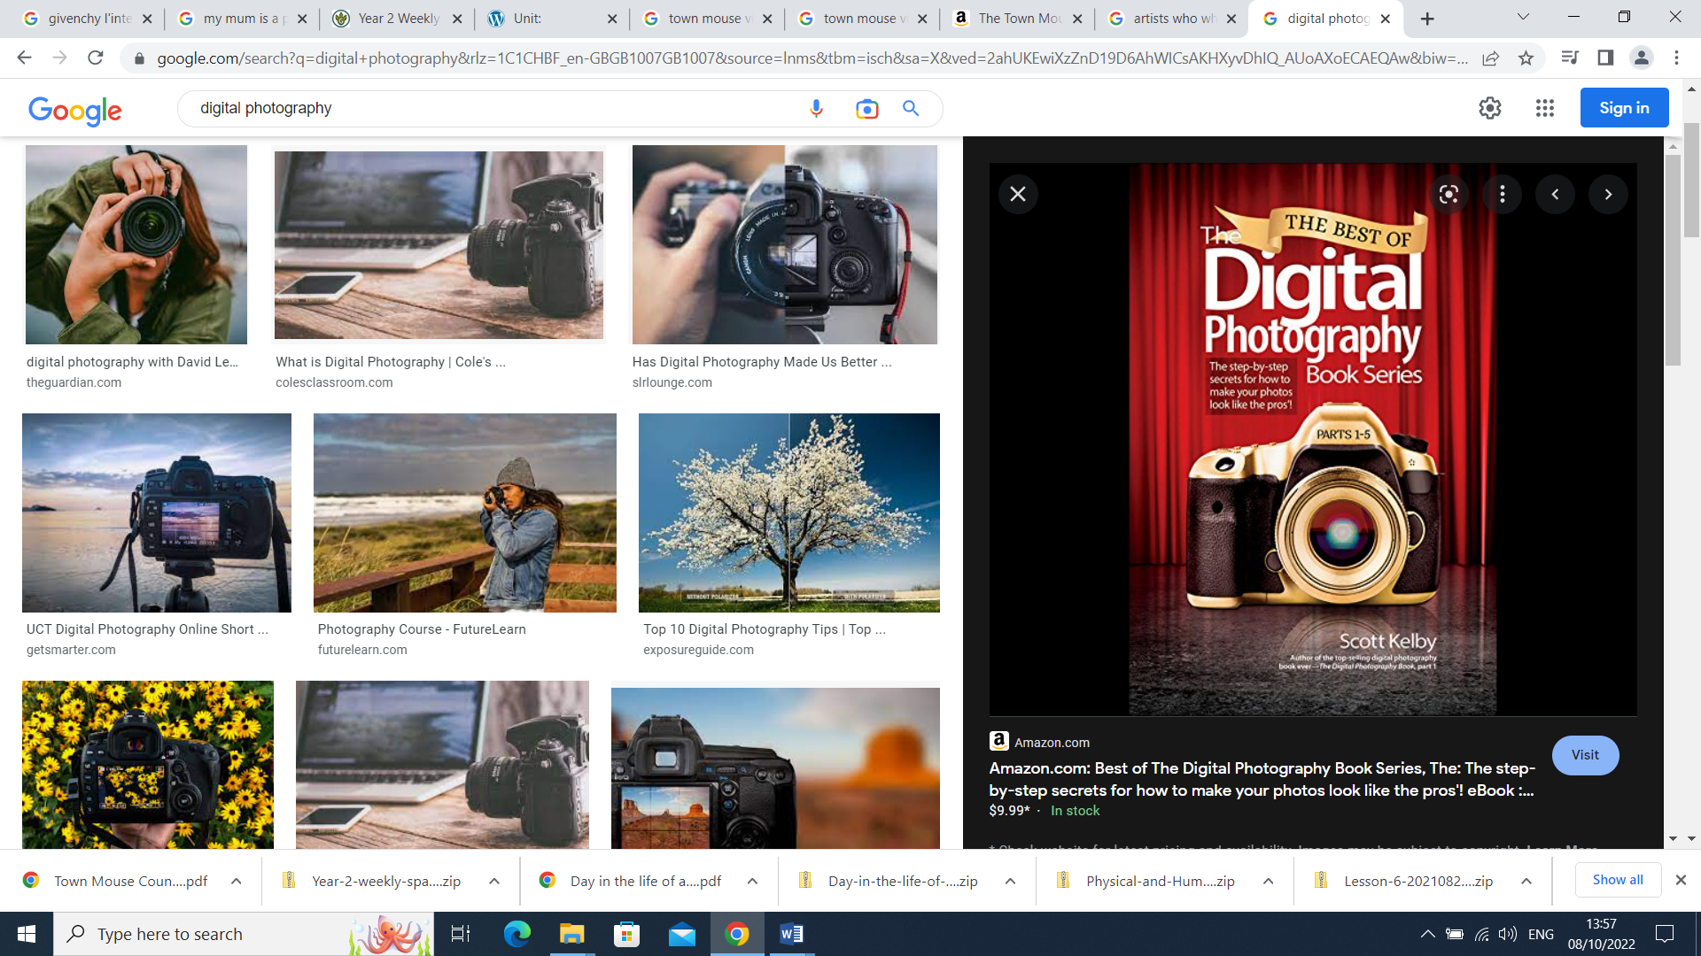 

In History and Geography, we will become Street Detectives by:

* Looking at changes in the past in our local environment.
* Using fieldwork, observational and map skills to study our local environment

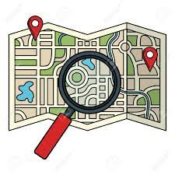

In our R.E topic ‘From Advent to Christmas” we will:

* Recognise, describe and explain the ‘O’ Antiphons and/or Jesse Tree as part of the season of Advent
* Become familiar with or retell Matthew’s account of the birth of Jesus

In Art and Design, we will:

* Learn about LC Lowry and his art
* Make drawings of buildings and statues from our local area

In Literacy we will be:

* Exploring different adventure books.
* Looking at creative writing and using adjectives to describe these adventures.
* Recount adventures that we have had or would like to go on.
* Using reading strategies to decode and explain new words and to retrieve and explain information.

Through our Street Detectives topic, we will:

* Write instructions to guide a visitor around our town and make lists of human and physical features.
* Design posters to tell everyone about our local environment.
* Invite local residents who could tell us about living in Finchley and how it has changed over the years.

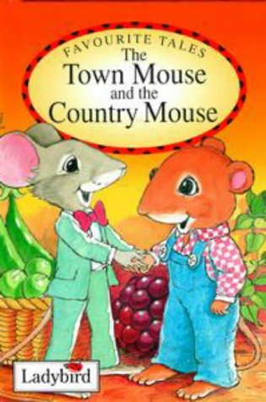

In our Mathematics learning the class will be looking at:

* Addition and Subtraction
* Money
* Multiplication and division
* Statistics – traffic survey

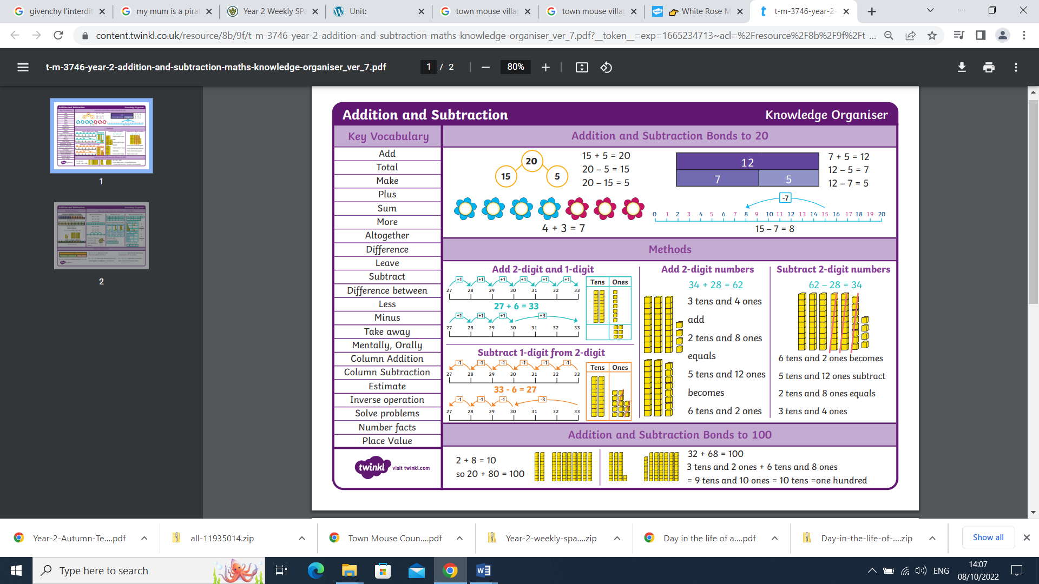

In Science we will be learning about health by:

* Looking at nutrition and exercise
* Understanding the importance of physical activity and rest
* Understanding why we should limit screen time
* Understanding the risks of too much sugar to my body
* Understanding the importance of dental hygiene 